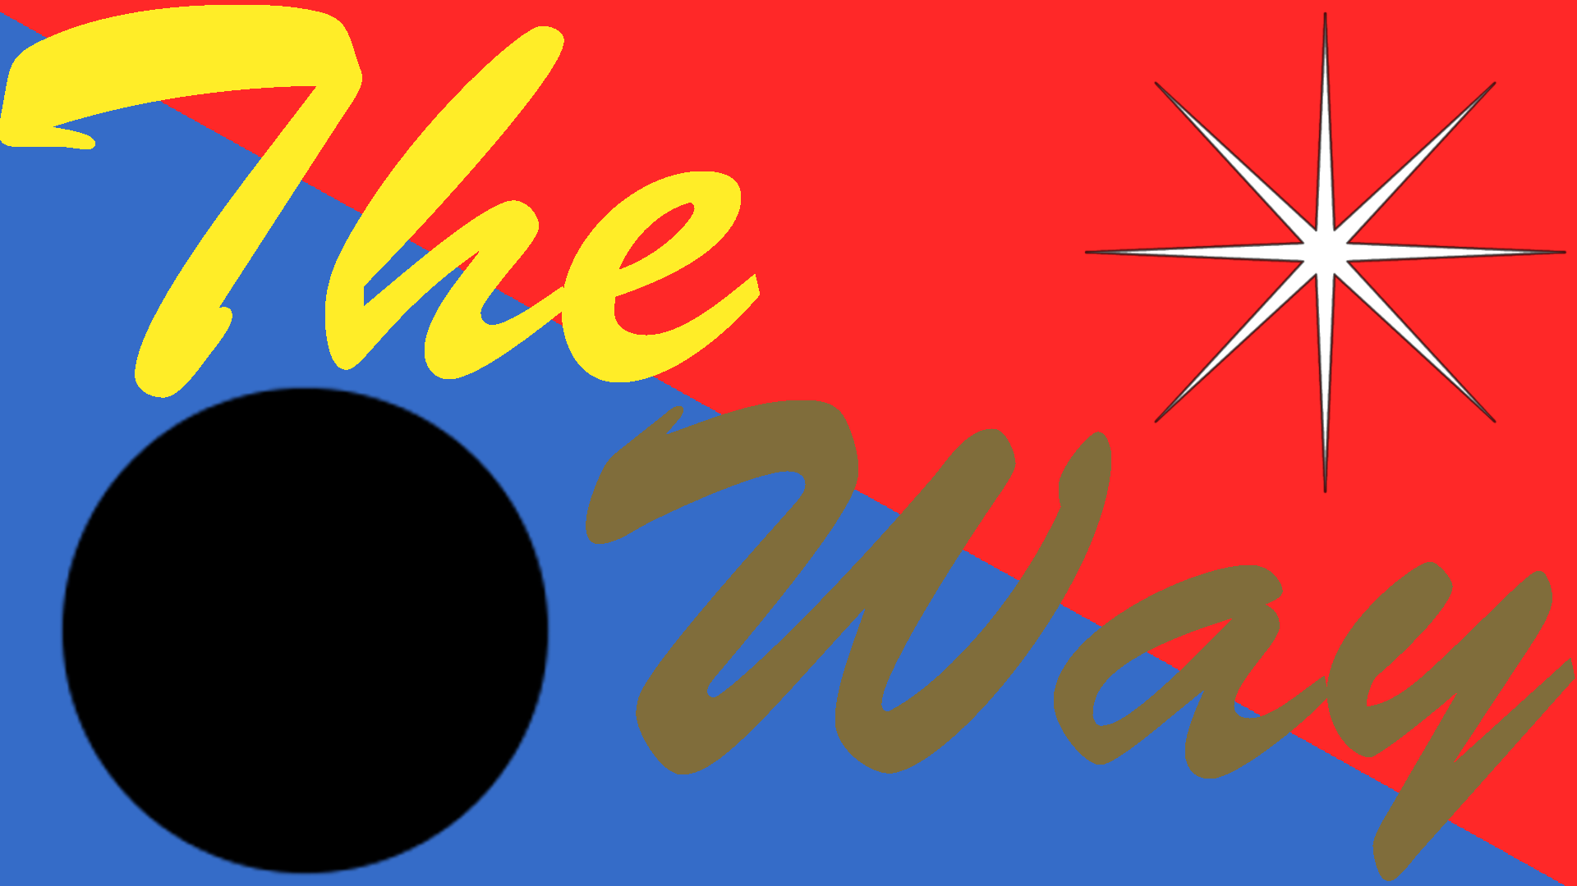
The Way Rule Set

Table of Contents

1. Setup 3

2. Play 3

3. End Conditions 3

4. Symbols 3

Setup for Versus Play

Place the board on the table.
Place one player piece for each player in the center of the board.
(In a 2 player game, each player place 2 player pieces for variety.)
Shuffle the card deck and deal 4 cards to each player.

Play

On each player's turn, they may perform one of the following actions:
Draw a card.
Play a card:
This can affect any piece.
This cannot result in a piece exiting the board through another player's side of the board.
A player piece does not move if:
It would move off the board (other than through its gate)
It would move into a space occupied by another piece
It is in the void (center) and is directed to move towards the void.
Cards work by targeting 1, 2, or all player pieces.
This is represented by the number of borders on the card:
1 set of borders
Cards with 1 set of borders will have 1 or 2 symbols, representing how far in the direction of the symbol to move the player piece.
2 sets of borders
Cards with 2 sets of borders will have 1 symbol in each set of borders, representing that the player may make 2 independent moves.
This can be:
One target twice.
Two targets once.
4 sets of borders
Cards with 4 sets of borders will have 1 symbol, representing 1 movement for ALL player pieces in the direction of the symbol.
Wild cards may move each piece in a different direction.
Discard a card to draw two cards.

End Conditions

A player is moved off of the board.
A player can only exit through their own gate.

Win Condition
The first player to move through their own gate wins.

Symbols
There are 4 basic and 2 advanced symbols that represent directions on the board:
Air: Moves a piece towards the yellow gate.
Earth: Moves a piece towards the brown gate.
Fire: Moves a piece towards the red gate.
Water: Moves a piece towards the blue gate.
Wild: Moves a piece in the direction of the player's choice.
Void: Moves a piece towards the center.

Setup for Cooperative Play

Place the board on the table.
Place all player pieces outside the gate opposite of their own.
Shuffle the card deck and deal 4 cards to each player.
Any void or 4 border cards ("events") are played immediately (from the first player, going left), and replaced them until no one has any events left.

Play
Each player starts their turn by drawing a card.
If that card is an event, then resolve that event immediately and replace the card.
On each player's turn, they may perform one of the following actions:
Draw a card.
Play a card:
This can affect any piece.
This cannot result in a piece exiting the board through another piece's side of the board.
A piece does not move if:
It would move off the board (other than through its gate)
It would move into a space occupied by another piece
It is in the void (center) and is directed to move towards the void.
Cards work by targeting 1, 2, or all player pieces.
This is represented by the number of borders on the card:
1 set of borders
Cards with 1 set of borders will have 1 or 2 symbols, representing how far in the direction of the symbol to move the player piece.
2 sets of borders
Cards with 2 sets of borders will have 1 symbol in each set of borders, representing that the player may make 2 independent moves.
This can be:
One target twice.
Two targets once.
4 sets of borders
Cards with 4 sets of borders will have 1 symbol, representing 1 movement for ALL pieces in the direction of the symbol.
"Wild" cards may move each piece in a different direction.
Discard a card to draw two cards.

Each player ends their turn by discarding from the draw deck. They draw and discard 2 cards for each piece that is not currently in its objective position. Discard these cards to a seperate "burn pile".

Arc 1 End Conditions
All player pieces are moved to the center of the board.
The card deck is depleted.

Arc 1 Win Condition
All player pieces are moved to the center of the board.

Arc 2
To extend gameplay, the players can try to move the pieces through their gates before the deck runs out. Shuffle the discard pile (but not the burn pile) back into the draw pile.

Arc 2 End Conditions
All players are moved off of the board.
A player can only exit through their own gate.

Arc 2 Win Condition
All players are moved off of the board.

Symbols

There are 4 basic and 2 advanced symbols that represent directions on the board:
Air: Moves a piece towards the yellow gate.
Earth: Moves a piece towards the brown gate.
Fire: Moves a piece towards the red gate.
Water: Moves a piece towards the blue gate.
Wild: Moves a piece in the direction of the player's choice.
Void: Moves a piece away from the center in Arc 1.
Moves a piece towards the void in Arc 2.

